GL and Budget vs. Actuals Markdown File

## How to use this document

This markdown file will use the DHCD Finance dept documents that are for reporting expenditures and GL data. The data is collected from Workday. I will be referring to each of the **code chunks** (the code chunk refers to anything that is located within the ```{r} ``` area) within the file and add more detailed information on how to complete each of the r code chunk actions.

Follow along with the rmarkdown file named GL_and_Budget_vs_Actuals

## IMPORTANT!!

* Please change the name of the files that you are reading into R based on what you are trying to complete for the analysis.
  + Example: gl_file_name <- "GL-Operating Actual Expenses YTD 2024-12-19 13_03 EST.xlsx" – *Change the time and month here see line 28*
  + Example: budg_vs_act_file_name <- "Budget_vs_Actuals_-_BBMR YTD 2024-12-19.xlsx" – *Change the time and month here see line 30*
* Please change the month as needed for this expression
  + Example: expense_report_tbl <- expense_report_tbl |> mutate ('GL YTD EXP' = ifelse (! is.na (August & August! = 0 &! is.na (July) & July! = 0), lag (August) / July,) – *Change the time and month here for which you are trying to divide by see line 206*

## Libraries/Packages Chunk

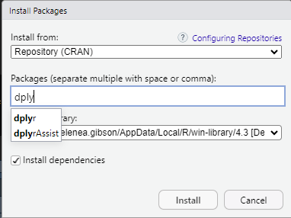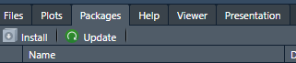Libraries – It important to read in the libraries before you can start working or else the code will not run. Some of the libraries may not be installed which will resort in an error upon reading. If that is the case, then make sure to install packages using the packages tab at the bottom of the page > click install > type in the package name > and then run it.

## Reading in the data Chunk

Read in your data from the folder that contains the data needed to complete the script. You can read in any file extension that R allows for like csv, xlsx, or shp.

Created a data frame or dataset that will house the data that we want as a variable to use for the analysis.

## Cleaning data Chunk

It is important to inspect the data that is read into R because it may be read oddly or not the same way that Excel does. For cleaning the data, you can perform multiple steps such as only reading in certain rows, making the column headers or names be a different format type like text, numeric, etc.… You can rename the column names to something that makes more sense to those who will be using the data.

Make sure that NA’s and NULL values are addressed

NA values are often not needed in datasets because you want to have a full dataset with no missing data. There are ways to address these values, and you can take them out in a few steps. An example is (na. rm = TRUE) – meaning that you are excluding na values. You can use (is.na ()) as well.

## Monthly amounts match Chunk

Aggregating the ledger data to calculate the monthly spendies dataset. Then we will compare the data frame that was just created to the original data frame.

Next is to apply a filter on the values that do not match the data frame to highlight areas that are of interest to the user. This is another way of double checking your work and addressing areas that may signify a value being smaller or bigger than the original data frame.

## Overall expenditures Chunk

Aggregating the ledger data to calculate the overall spendies dataset. Then we will compare the data frame that was just created to the original data frame.

Next is to apply a filter on the values that do not match the data frame to highlight areas that are of interest to the user. This is another way of double checking your work and addressing areas that may signify a value being smaller or bigger than the original data frame.

## Making the output table Chunk

This will be a series of chunks and r coding to complete the excel table that is needed. This and the following code chunks will allow for the data to be implemented into a format that can be easily accessible and interpreted for DHCD.

## Creating the Excel workbook Chunk

Using html formatting to construct a excel table that can be used to report the `754 SFSP Expense Report`. It is very critical that this table works not just in r but also in excel as that is where the report will be exported to for further analysis by the DHCD finance team.

There are smaller steps within the chunk to understand what each of the code lines are doing and how it works.

Once everything is completed and finished it is important to look through the completed datasets in your local drive to make sure that it is okay. Also keep in mind that this is what others will be seeing as well once the file is completed, so do not add anything that you do not want others to see in the file.